Week-2
- a) Create and attach an EBS volume to an EC2 instance, and
- scale the instance by increasing CPU and RAM by changing the instance type.
2.Attach and permanently mount an EBS volume to a Linux EC2 instance to ensure data persistence across reboots.
3. Create a snapshot of the attached EBS volume and use it to create and attach a new volume to an EC2 instance in another AWS region.
- a) Create and attach an EBS volume to an EC2 instance, and
- scale the instance by increasing CPU and RAM by changing the instance type.

- Creating and attaching an EBS volume to an EC2 instance
Step 1: Create a New EBS Volume
Open the EC2 Dashboard.
From the left-hand menu, select Volumes under Elastic Block Store (EBS).
Click Create Volume.
Choose:
Volume type (gp3/gp2)
Size of the volume
Availability Zone (must be the same as the EC2 instance)
Click Create Volume.

Go to the EC2 instance->EBS-> Select the volume-->create volume ->Volume settings-->change if required-->make sure the same ec2 zone-->click on create volume

Step 2: Attach the EBS Volume to the Existing EC2 Instance
- In the Volumes section, select the newly created volume.
- Click Actions → Attach Volume.
- Select the target EC2 instance from the list.
- Specify the device name (example: /dev/xvdf).

For Linux EC2 instances (Amazon Linux, Ubuntu, RHEL, etc.)
Use any unused device name such as:
- /dev/xvdf ✅ Most commonly used
- /dev/xvdg
- /dev/xvdh
- /dev/sdf (AWS internally maps this to xvdf)
Best practice:
Use /dev/xvdf for the first additional volume.
- Click Attach.
Go to the EC2 instance->actions->attach-select the instance->device name as /dev/xvdf--->attach volume
Note: Root volume is disabled

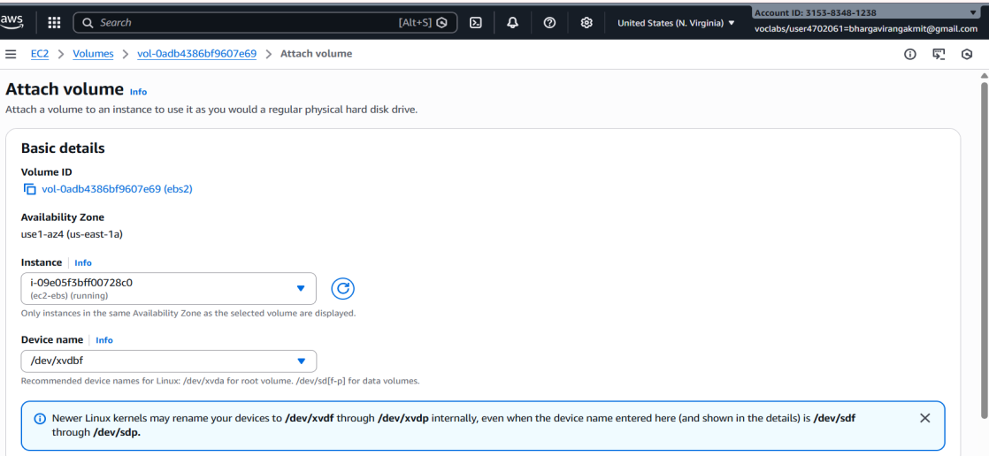
Attach Volume settings:
Instance : my-ec2-instance
Device : /dev/xvdf

Note : Attach and detach operations are allowed only for additional EBS volumes, not for the root EBS volume, and can be done from the Instance Storage tab or the Volumes page.
Step 3: Verify the Volume on the EC2 Instance
Connect to the EC2 instance using SSH.
Check the attached disks:List Block devices

lsblk
Identify the new volume (e.g., /dev/xvdf).
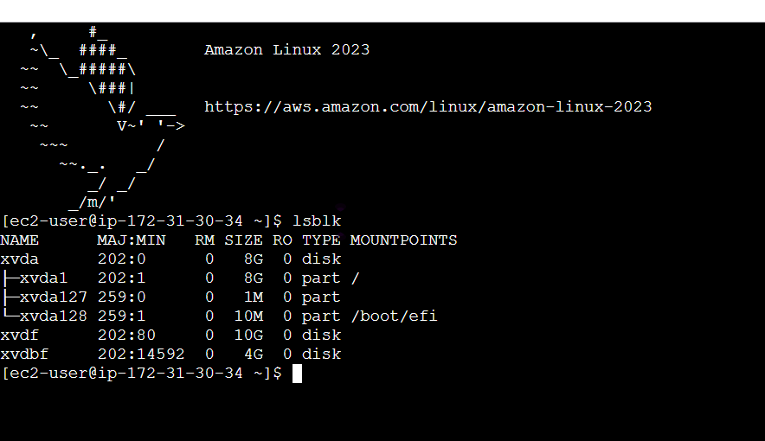
Note: Ensure that the EBS volume and the EC2 instance belong to the same Availability Zone, as cross-AZ attachment is not supported.

b)Procedure: increasing/decreasing of CPU and RAM
Step 1. - Navigate to the EC2 dashboard.
Step 2. - Stop the EC2 instance associated with the EBS volume.
Step 3. - Click "Actions" in EC2 INSTANCE and then—instance settings—change the instance type"Modify Volume".
Step 4. -Increase/ decrease the size or change the volume type to a higher performance specification.
Step 5. - Click "Modify" to apply the changes.
Step 6: Now the start the machine you see with increase /decrease of size and performance

Step 1:
Navigate to AWS Console → EC2 Dashboard
Step 2:
Select the EC2 instance
Step 3:
Click Instance state → Stop instance
Instance must be stopped
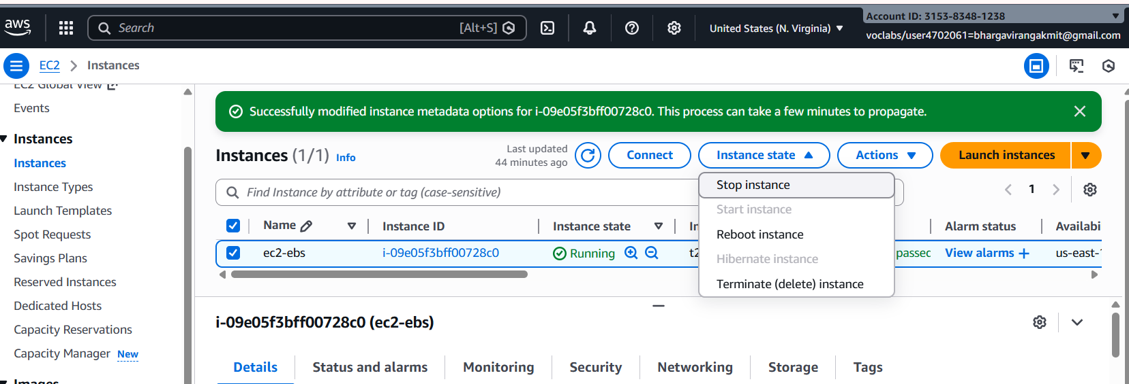

Step 4:
Click Actions → Instance settings → Change instance type
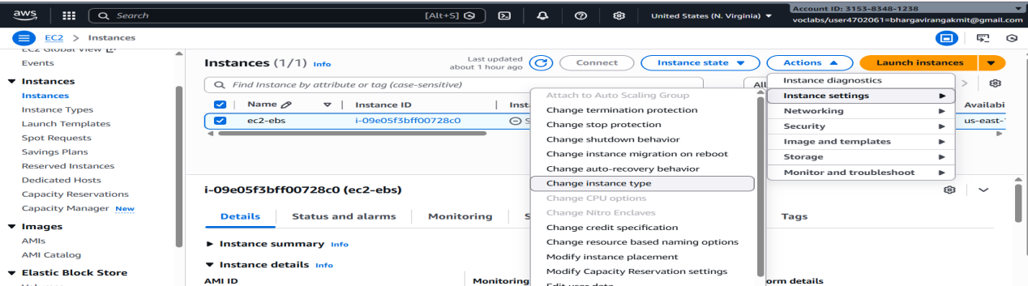
Step 5:
Select a new instance type
(e.g., t2.micro → t2.medium)
This changes CPU & RAM

2.Attach and permanently mount an EBS volume to a Linux EC2 instance to ensure data persistence across reboots.
Step 1: Create an EBS Volume
- Log in to AWS Management Console
- Go to EC2 → Volumes
- Click Create Volume
- Choose:
  - Volume Type: gp3 (recommended)
  - Size: (e.g., 20 GB)
  - Availability Zone: Same AZ as EC2 instance
- Click Create Volume
Step 2: Attach the EBS Volume to EC2
- Select the newly created EBS volume
- Click Actions → Attach Volume
- Choose:
  - Instance: Select your Linux EC2 instance
  - Device name: /dev/xvdf
- Click Attach
Step 3: Connect to the EC2 Instance
Connect using SSH:
ssh -i key.pem ec2-user@<public-ip>
Ssh -i f.pem ec2-user@
Step 4: Verify the Attached Disk
Check all available disks:
lsblk
You will see:
- Root volume: /dev/xvda
- New volume: /dev/xvdbf (no partition yet)
Check filesystem:
lsblk -fs

Note: display detailed filesystem information for all block devices.
• xvda1 → Root filesystem, mounted at /
• xvdf → Additional EBS, formatted as ext4 and mounted at /data
• lsblk → List block devices
• -f → Show filesystem info (TYPE, UUID, LABEL)
• -s → Show parent → child relationship (device hierarchy)
Step 5: Create a Partition
Create a partition on the new volume:
sudo fdisk -l
List all the disks
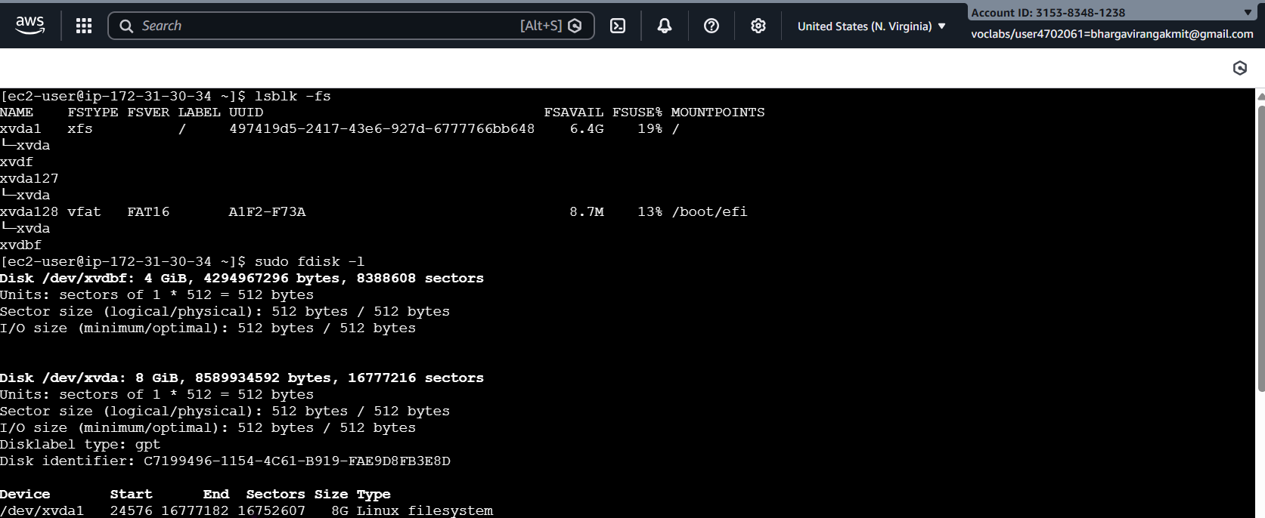

sudo fdisk /dev/xvdf
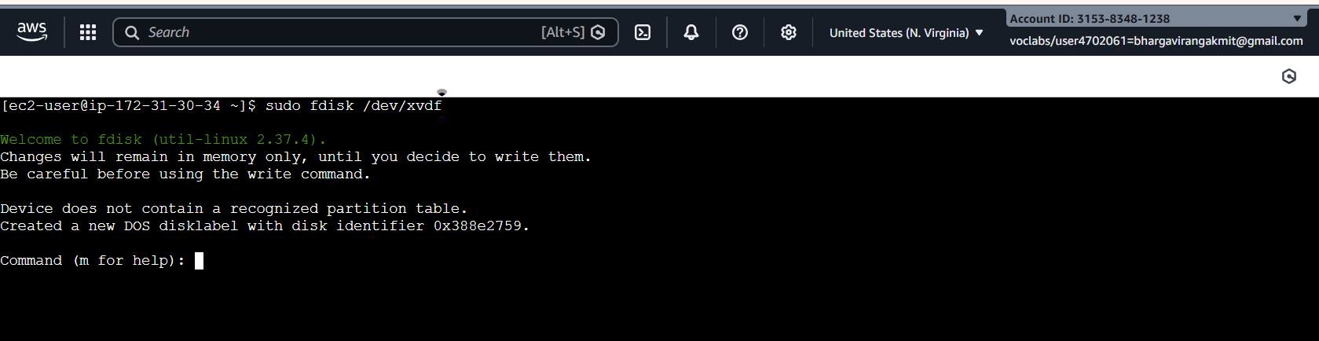
Inside fdisk:
- Press m → Help menu
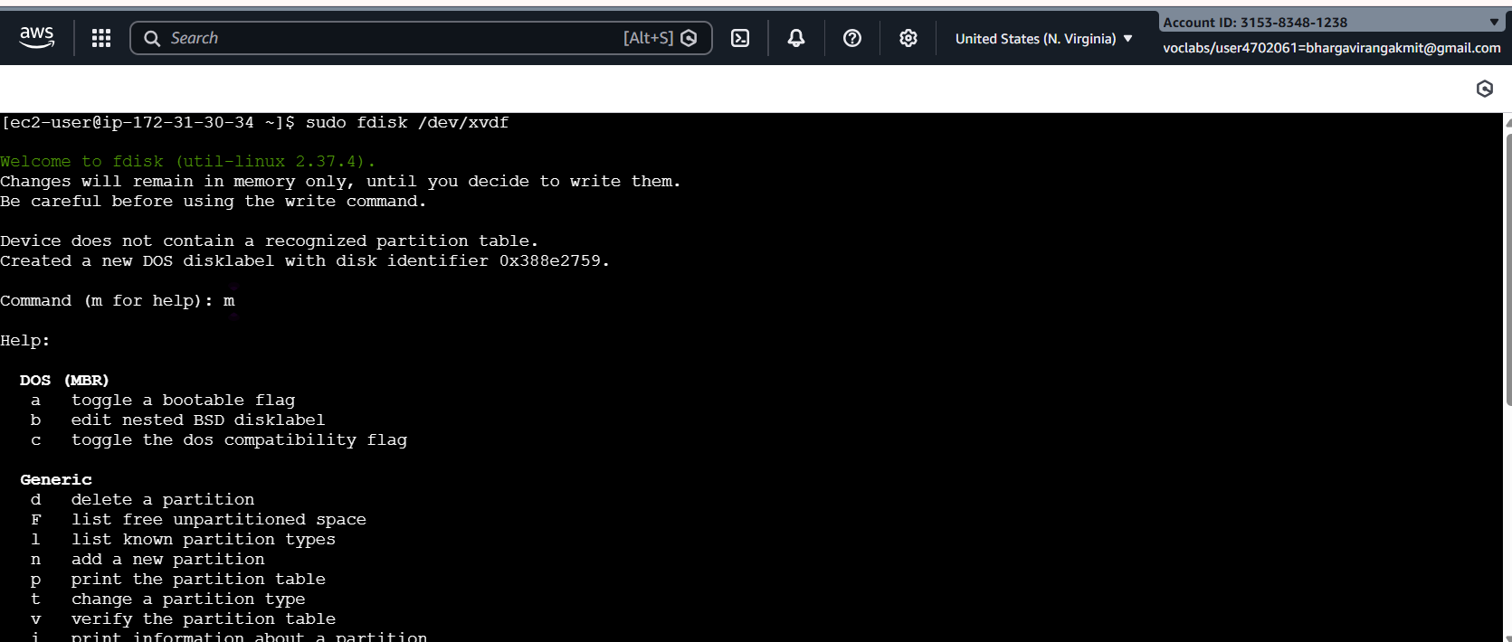
- Press n → New partition
- Press p → Primary partition
- Press Enter → Default partition number
- Press Enter → Default first sector
- Press Enter → Default last sector (use full disk)

- Press w → Write changes and exit
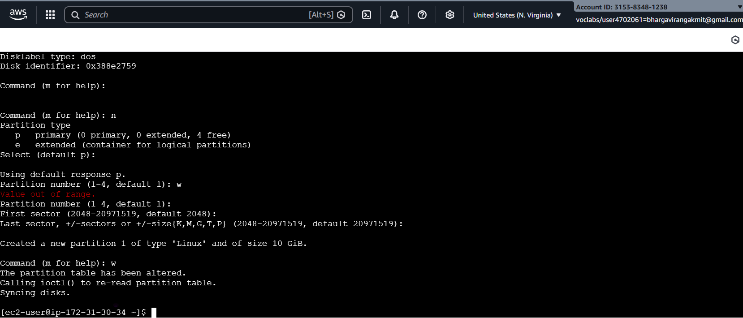

Notify kernel:
partprobe
Step 6: Verify the New Partition
lsblk -fs
You should now see:
/dev/xvdf1
Step 7: Format the Partition mkfs -t ext4 /dev/xvdbf1
Format with XFS filesystem: mkfs.xfs → creates an XFS filesystem on the specified partition.
By default, it will wipe any existing data on /dev/xvdf1.
mkfs.xfs /dev/xvdf1
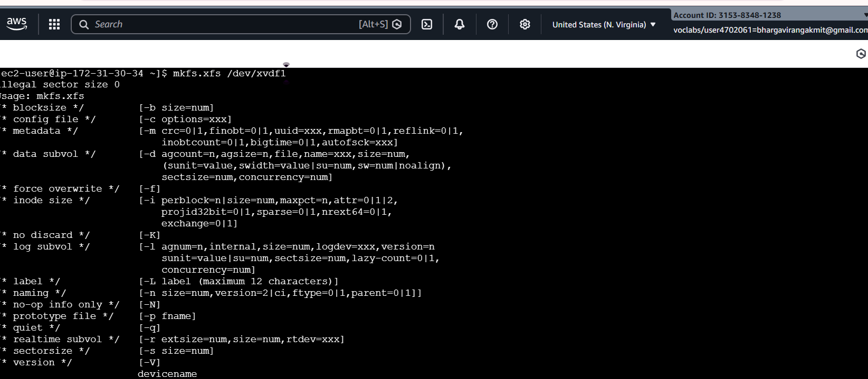

Verify:
lsblk -fs

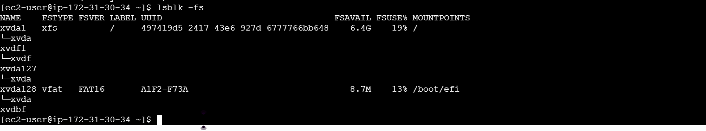

Step 8: Create a Mount Directory
sudo mkdir -p /mnt/bhargavi
ls -ld /mnt/bhargavi

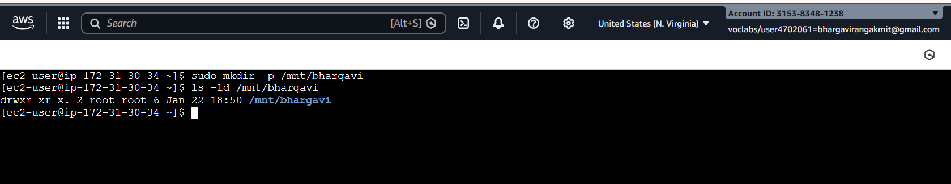
mkdir → makes a new directory.
-p → ensures parent directories are created if they don’t exist.
/mnt/bhargavi → you can replace bhargavi with any name you like, e.g., CSMA
Step 9: Mount the Volume/Check Mounted Partitions
mount /dev/xvdbf1 /mnt/bhargavi
Verify:
df -h
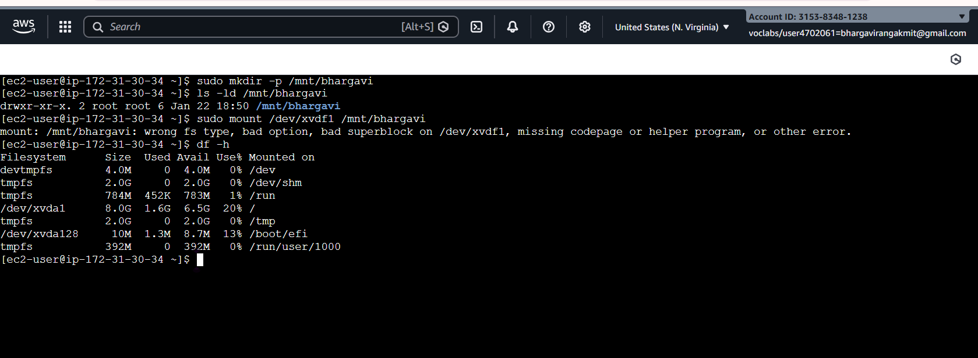
Step 10: Make the Mount Persistent

Step : Find the UUID of the Partition
Using the UUID is safer than using the device name (/dev/xvdf1) because device names can change on reboot.
sudo blkid /dev/xvdf1
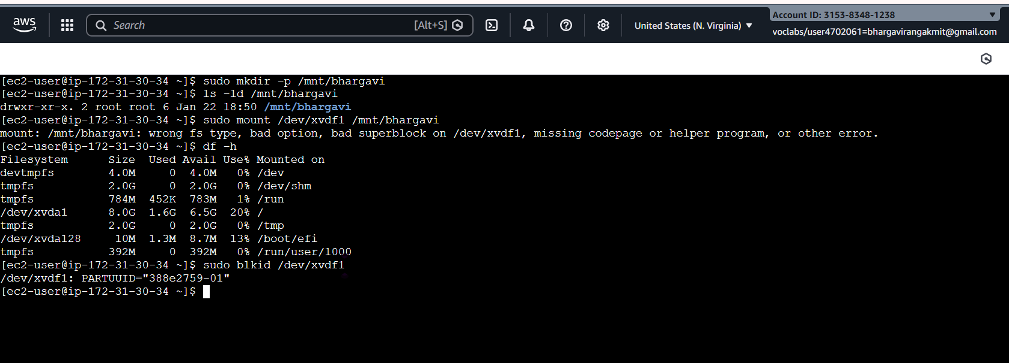

Step : Edit /etc/fstab
Open /etc/fstab with a text editor:
sudo nano /etc/fstab
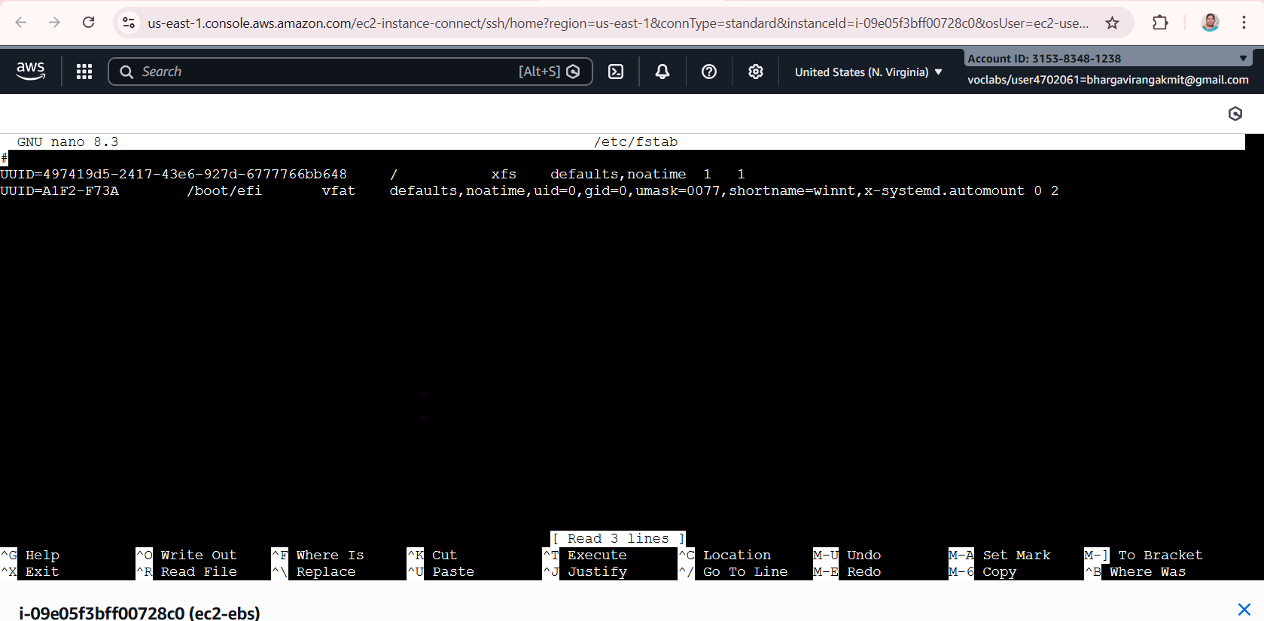

Add this line at the end:
Add the following line at the end of the file:
UUID=abcd-1234-ef56-7890 /mnt/bhargavi xfs defaults,nofail 0 0
UUID=... → The UUID of your partition
/mnt/bhargavi → Your mount point
xfs → Filesystem type
defaults → Standard mount options
nofail → Ensures boot continues even if this disk is missing
Last two 0 0 → dump and fsck options (safe for XFS)
Save and exit (Ctrl+O, Enter, Ctrl+X in nano).
Test fstab:
mount -a
df -h | grep bhargavi
mount | grep bhargavi

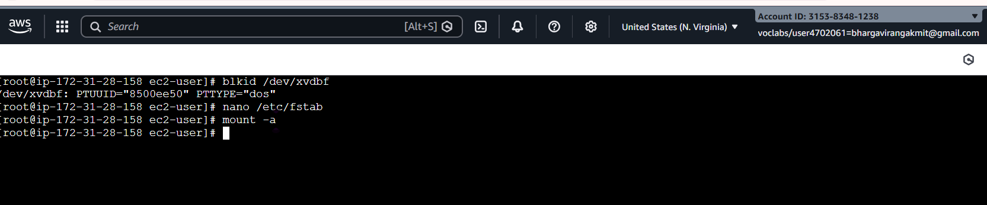
sudo touch /mnt/bhargavi/testfile
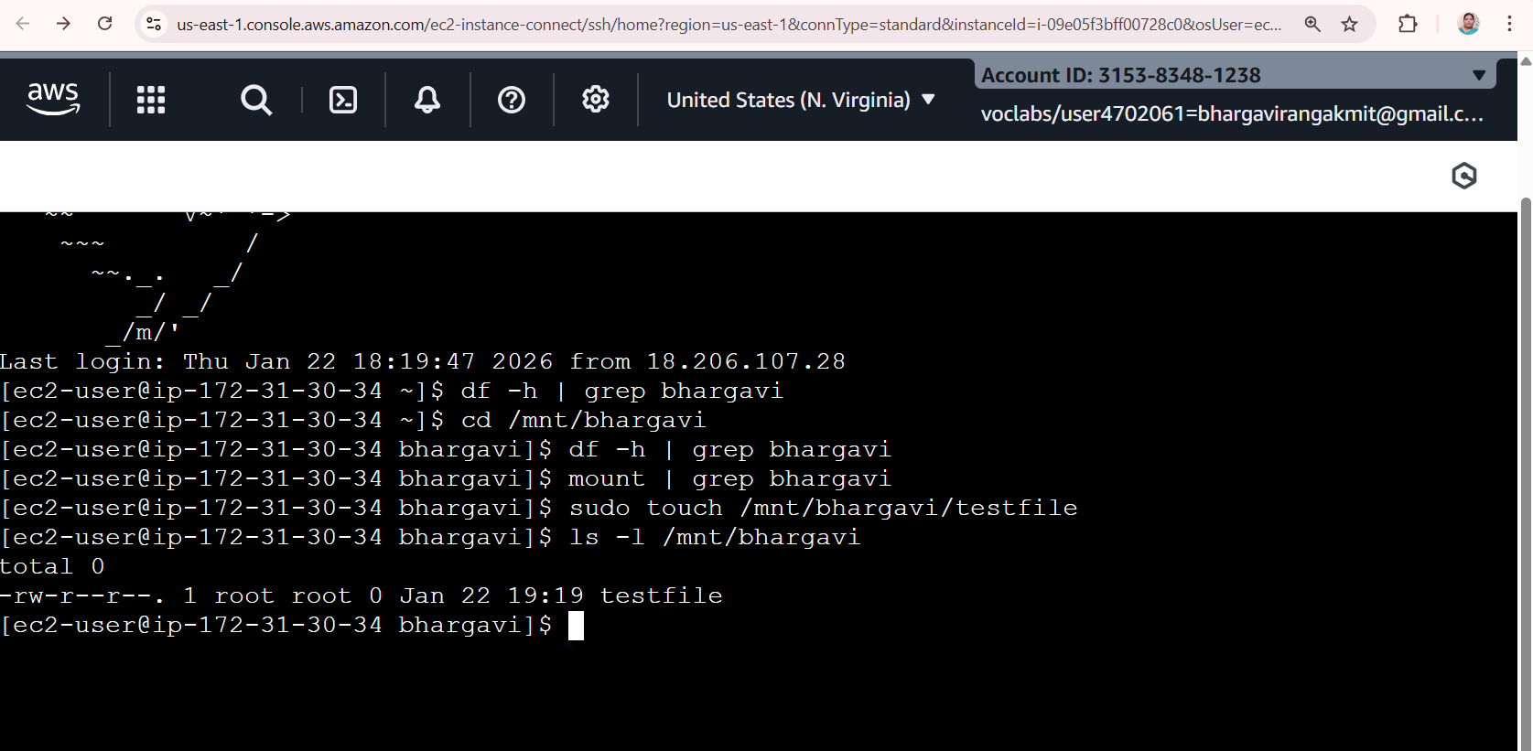

Step 11: Verify Persistence
- Reboot the instance:
reboot
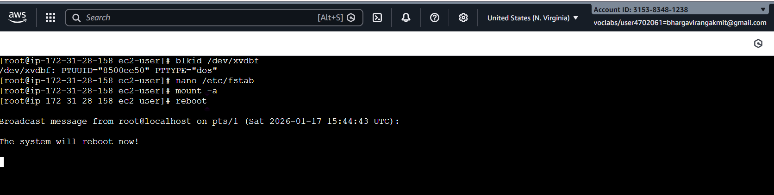

- Reconnect and check:

Reboot via Terminal (SSH / CloudShell)
From your EC2 terminal, run:
sudo reboot
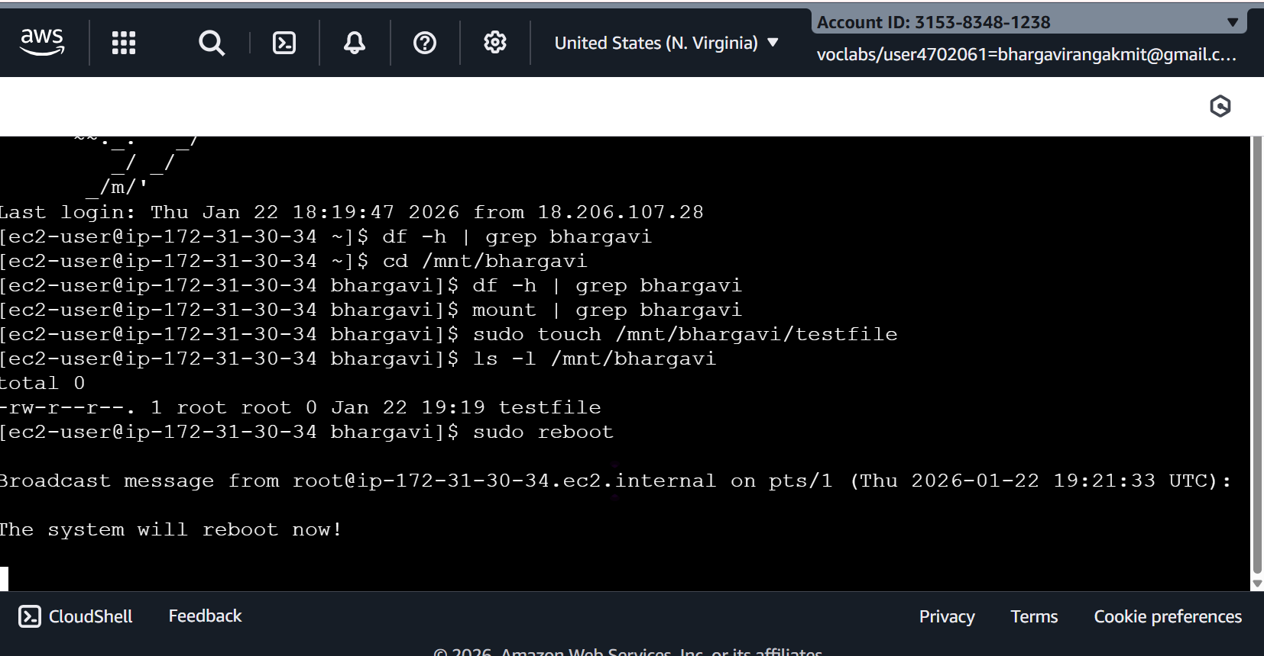

df -h
➡️ Volume should be mounted automatically.
Step 12: Detach and Reattach Volume (Data Recovery Scenario)
Detach:
- EC2 → Volumes → Select volume
- Actions → Detach volume
Attach to another EC2 instance:
- Attach to new instance (same AZ)
- Login to new instance
- Create mount directory:
mkdir /mnt/bhargavi
- Mount the volume:
mount /dev/xvdf1 /mnt/bhargavi
All previous data will be available
Summary Flow
Create Volume → Attach → lsblk → fdisk → mkfs → mkdir → mount → fstab → reboot

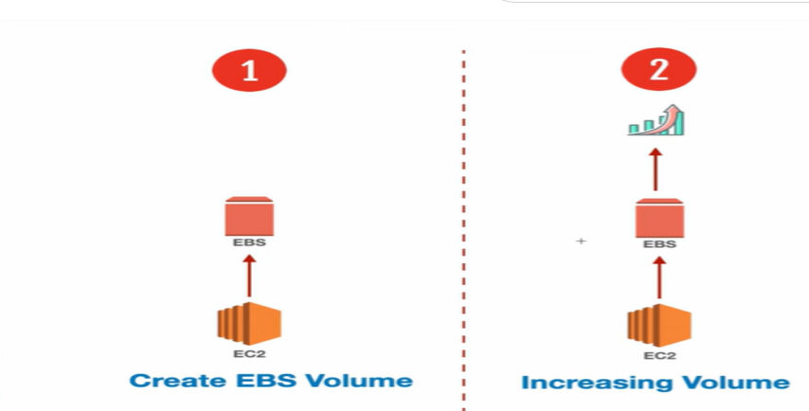
3. Create a snapshot of the attached EBS volume and use it to create and attach a new volume to an EC2 instance in another AWS region.
Attaching Volumes across regions of EC2 using the snapshot
To create a snapshot of an EBS volume and attach it to an instance in another region in AWS, you'll need to follow these steps:

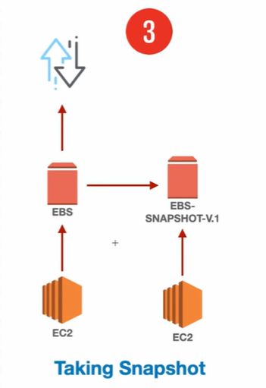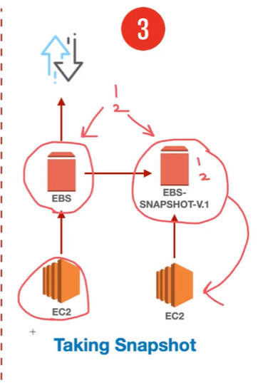

Step 1. Create a Snapshot:
a. Sign in to the AWS Management Console.
b. Navigate to the EC2 Dashboard.
c. Click on "Volumes" in the left-hand navigation pane.
d. Select the EBS volume you want to create a snapshot of.
e. Click on the "Actions" dropdown menu above the volume list and select "Create Snapshot."
f. Provide a name and description for the snapshot.
g. Click on the "Create Snapshot" button to initiate the snapshot creation process.

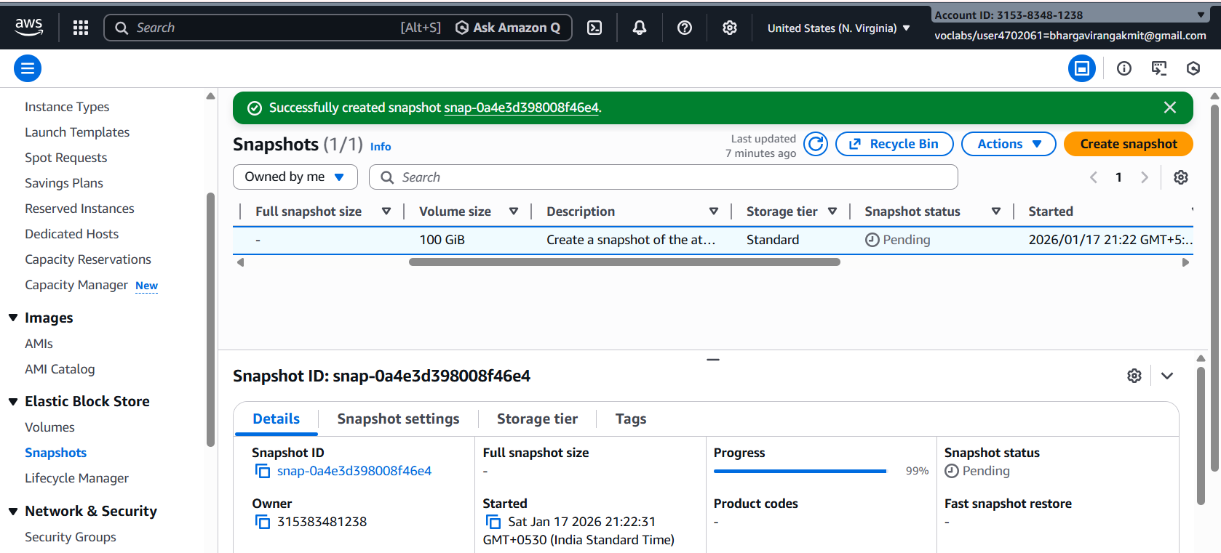

Once created
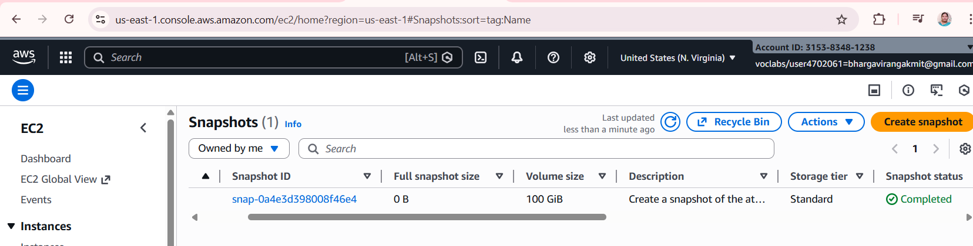
Step 2. Copy the Snapshot to Another Region:
a. Once the snapshot is created, go to the "Snapshots" section in the EC2 Dashboard.
b. Select the snapshot you just created.
c. Click on the "Actions" dropdown menu above the snapshot list and select "Copy Snapshot."
d. Choose the destination region where you want to copy the snapshot.
e. Click on the "Copy Snapshot" button to initiate the copy process. This may take some time depending on the size of the snapshot and the network speed.

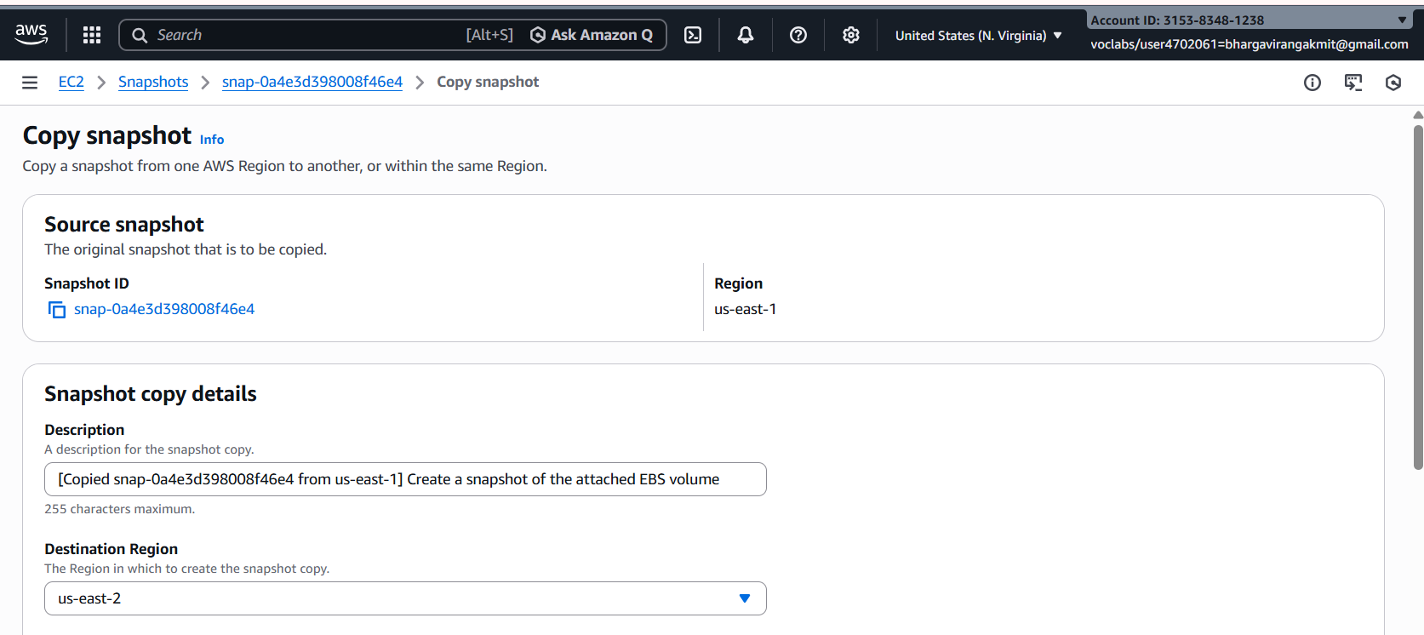

Step 3. Monitor the Snapshot Copy Progress:
a. You can monitor the progress of the snapshot copy by navigating to the "Snapshots" section in the EC2 Dashboard of the source region.
b. Look for the snapshot you copied and check its status. It will change from "pending" to "completed" once the copy process is finished.

Step 4. Switch to the Destination Region:
- Use the region selector in the top-right corner of the AWS Management Console to switch to the destination region where you copied the snapshot.

Step 5. Create a Volume from the Snapshot:
a. In the EC2 Dashboard of the destination region, go to the "Snapshots" section.
b. Find the snapshot you copied from the source region.
c. Click on the snapshot, then click on the "Actions" dropdown menu and select "Create Volume."
d. Configure the volume settings, such as volume type, size, and availability zone.
e. Click on the "Create Volume" button to create the volume from the snapshot.

Step 6. Create the ec2 instance & Attach the Volume to an Instance:
a. Once the volume is created, navigate to the "Volumes" section in the EC2 Dashboard.
b. Find the newly created volume and select it.
c. Click on the "Actions" dropdown menu and select "Attach Volume."
D the EC2 instance to which you want to attach the volume and specify the device name.
e. Click on the "Attach" button to attach the volume to the instance.

We have created a snapshot of an EBS volume, copied it to another region, created a volume from the snapshot, and attached it to an instance in the destination region.

